Grand Cherokee Data Analysis
I started my EDA by investigating a dataset on Kaggle. It had various car information, including seller location and trim level. I knew I wanted to train a model to predict car prices, but I had limited data.
The first step was choosing a model. I was unfamiliar with the Jeep Grand Cherokee, but when I filtered cars by Make and Model, this was the most popular car. This mattered because models wouldn’t have enough data purely based off raw data. For example, if I tried to get the model to predict the price while including every model, I would then have to control for models that only had a few entries. This was alleviated by choosing the most popular model.
By choosing the Jeep Grand Cherokee, I was able to remove most of the data from the list, such as comfort score, engine size, fuel economy and color. This led to only a handful of features, namely Mileage, Year, and buyer/seller information. All my data was already standardized, except for the year, which I dropped and turned into an Age column. I encoded the categorical data and proceeded.
Once my data was filtered down the Jeep Grand Cherokee, I did a quick analysis of the relevant columns, printing my notes in a prettier table. I noted visually and statically the skew of the car prices. The skew was further explained when I made box plots, a new concept for me, and visualized the outliers. I made the decision to omit all data outside of the whiskers, which led to a more normal distribution.
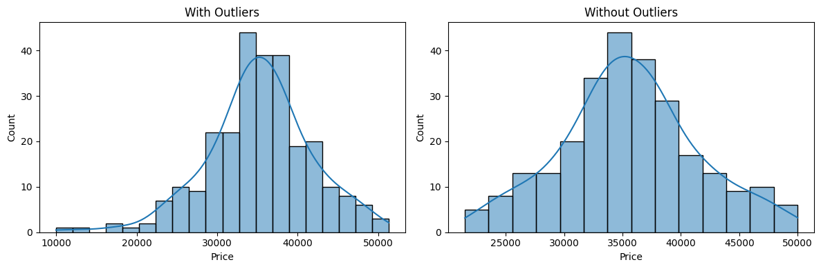
I had several moments where I went back and forth between the stages of EDA because truths were starting to reveal themselves. For example, while I knew the regression work wasn’t ready, I could already tell there was a clear correlation in the age of the vehicles and the price when I plotted them together.

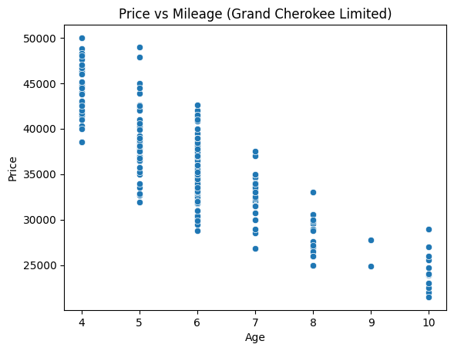

The heatmap was also essential in guiding my decision making to only include Age in Mileage in predicting the Price. While Consumer Reviews appeared to play a role in the price of a car, Consumer Reviews were consistent, with almost all cars being 4.8.
While the heatmap and tests reinforced the relevance of the features I selected, the ANOVA testing provided interesting insights. ANOVA was powerful in comparting groups against each other. While more complicated relationships could be studied (such as comparing multiple groups), I choose to compare 1 group at a time with nested for loops. I was mainly concerned about Price, but ANOVA revealed patterns between various categories, such as Seller Name and Mileage.
The feature importance test guided me in selecting the top two features for training and evaluation. I was pleased to observe that the model predicted car prices with an average error of $2744, which was impressive. I was aware that age and mileage significantly influenced the price by that point, but I was not surprised. Subsequently, I conducted a feature importance analysis for the Honda CR-V, the model with the second highest number of rows, and reaffirmed my suspicions that age and mileage played the most significant roles in predicting price.
In a final test, I manually selected Jeep Grand Cherokees from CARFAX and assessed my model’s ability to forecast prices. In each instance, the model deviated significantly beyond the predefined error threshold, although it exhibited some correlation with the vehicles. Despite the model’s inability to accurately predict these prices, which originated from a distinct source, I found the results intriguing, providing insights into the model’s performance capabilities.
This project presented significant challenges, necessitating my meticulous focus on achieving my objectives. While I endeavored to remain steadfast in my pursuit of Price, the comprehensive analysis of patterns and feature testing prompted me to explore alternative methodologies for data interpretation. Prior to this assignment, I held a reasonable understanding of the substantial influence of age and mileage on car prices. However, the data exploration process unveiled the profound impact of these factors on the final price. Had I had additional time, I would have conducted further experimentation with various tests and investigated distinct relationships, such as those between location and car prices.

